How to Make a Colorful Pinwheel

***Materials Provided:***

8 Colored Triangles

1 pipe cleaner

2 beads

2 colored circles

***Materials Needed:***

Glue Stick

Hot Glue

Hot Glue Gun

Scissors

One (1) Pushpin or Thumbtack

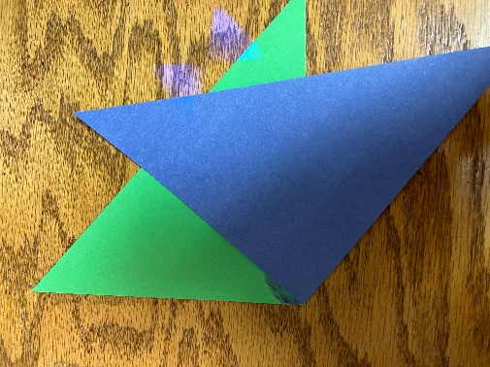

***Directions***

1. Take one circle.
2. Glue the 90 degree corner in the center of the circle with the glue stick.
3. 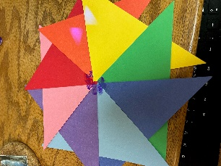Repeat turning 45 degrees until all triangles are attached.
4. Flip first triangle point over last triangle
5. Glue outside point of each color to the center with the glue stick.
6. Glue the second circle over the points you just glued down.
7. 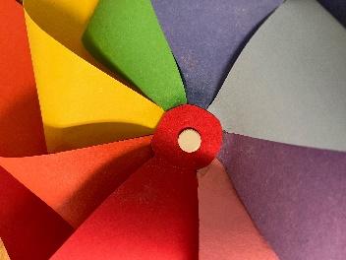Take the thumbtack/pushpin and push it through the center of the center circle.
8. Now remove the thumbtack/pushpin from the pinwheel and set it aside.

1. Take the pipe cleaner and cut off about two inches of the fuzz from one end.
2. Place one bead onto the pipe cleaner from the less fluffy side.
3. Poke the less fluffy side pipe cleaner through the back of the pinwheel hole that you make with the thumbtack.
4. Place the second bead onto the less fluffy side of the pipe cleaner.
5. Bend the tip of the pipe cleaner over to keep the bead from falling off.
6. Take the hot glue gun and glue the beads to pipe cleaner WITHOUT sticking them to the pinwheel (this helps the stability of the pinwheel).
7. Wrap the long end of the pipe cleaner around a pencil and tip the pinwheel sideways.
8. Great job! Now you can go have fun with your new pinwheel pencil topper. ☺